**DAILY ONLINE ACTIVITIES SUMMARY**

|  |  |  |  |  |  |  |  |  |
| --- | --- | --- | --- | --- | --- | --- | --- | --- |
| **Date:** | **08/06/2020** | | | | | **Name:** | **Shwetha** | |
| **Sem & Sec** | **8th B** | | | | | **USN:** | **4AL16CS101** | |
| **Online Test Summary** | | | | | | | | |
| **Subject** | | **SMS** | | | | | | |
| **Max. Marks** | | **60** | | **Score** | | | **60** | |
| **Certification Course Summary** | | | | | | | | |
| **Course** | **Introduction to cyber security** | | | | | | | |
| **Certificate Provider** | | | **Great learning** | | **Duration** | | | **7hr** |
| **Coding Challenges** | | | | | | | | |
| **Problem Statement:**  **Program to generate all unique partition of integer.** | | | | | | | | |
| **Status: Solved**  **Solution link: https://github.com/alvas-education-foundation/Shwetha-** | | | | | | | | |
| **Uploaded the report in Github** | | | | | **Yes** | | | |
| **If yes Repository name** | | | | | **Shwetha-** | | | |
| **Uploaded the report in slack** | | | | | **Yes** | | | |

Online Test Details:

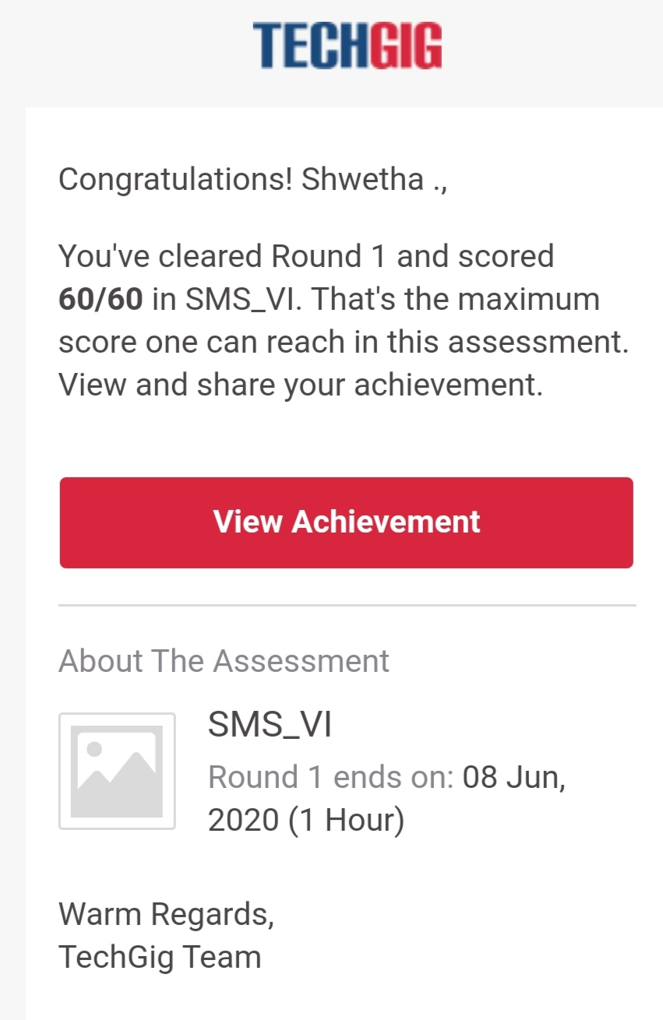

Certification Course Details:

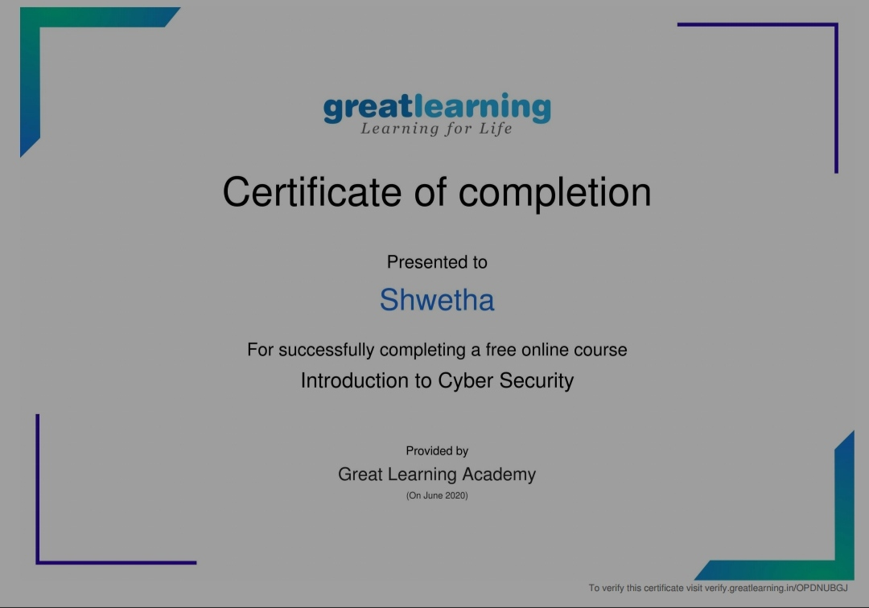

*Coding Challenges Details:*

defprintArray(p,n):

foriinrange(0,n):

print(p[i],end="")

print()

defprintAllUniqueParts(n):

p=[0]*n #Anarraytostoreapartition

k=0 #Indexoflastelementinapartition

p[k]=n #Initializefirstpartition

#asnumberitself

whileTrue:

printArray(p,k+1)

rem_val=0

whilek>=0andp[k]==1:

rem_val+=p[k]

k-=1

ifk<0:

print()

return

p[k]-=1

rem_val+=1

whilerem_val>p[k]:

p[k+1]=p[k]

rem_val=rem_val-p[k]

k+=1

p[k+1]=rem_val

k+=1

print('AllUniquePartitionsof2')

printAllUniqueParts(2)

print('AllUniquePartitionsof3')

printAllUniqueParts(3)

print('AllUniquePartitionsof4')

printAllUniqueParts(4)